**Plagiarism Validation Project**

**Team ID: 32**

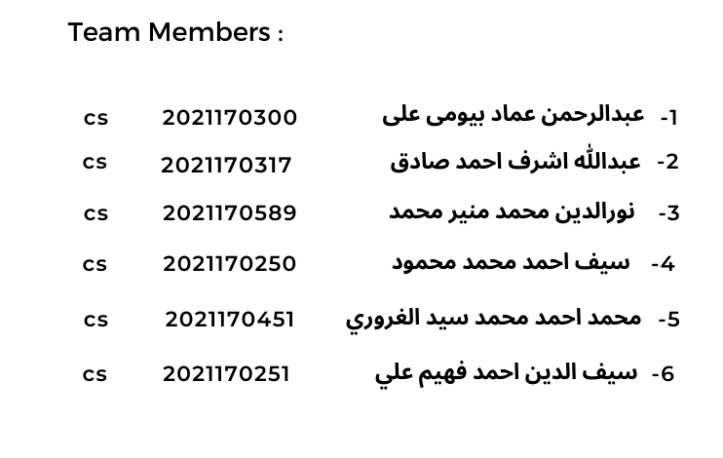

**The Entire Source Code and it’s Detailed Analysis**

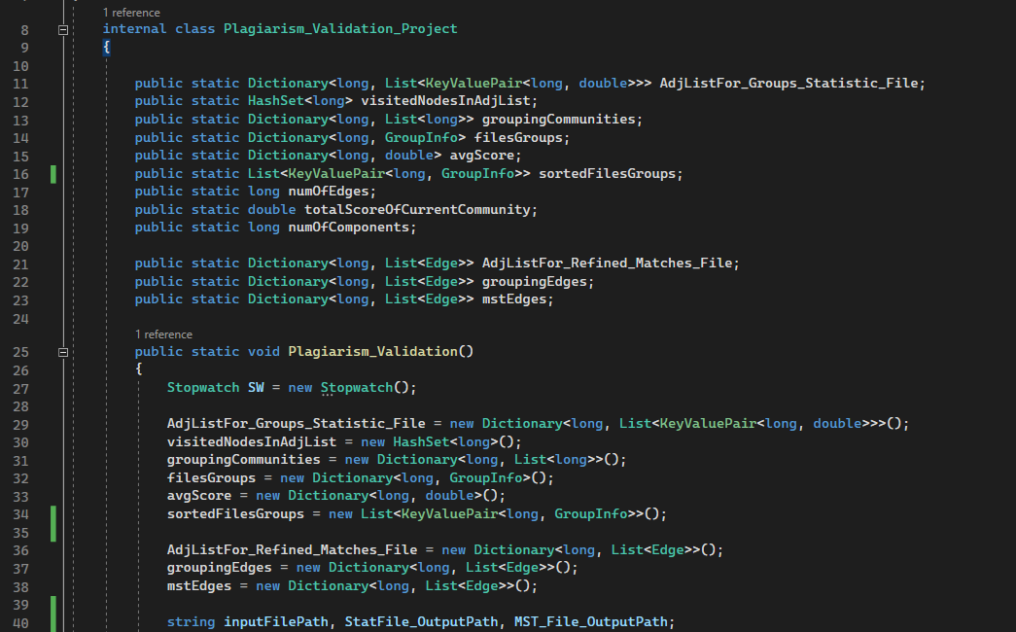

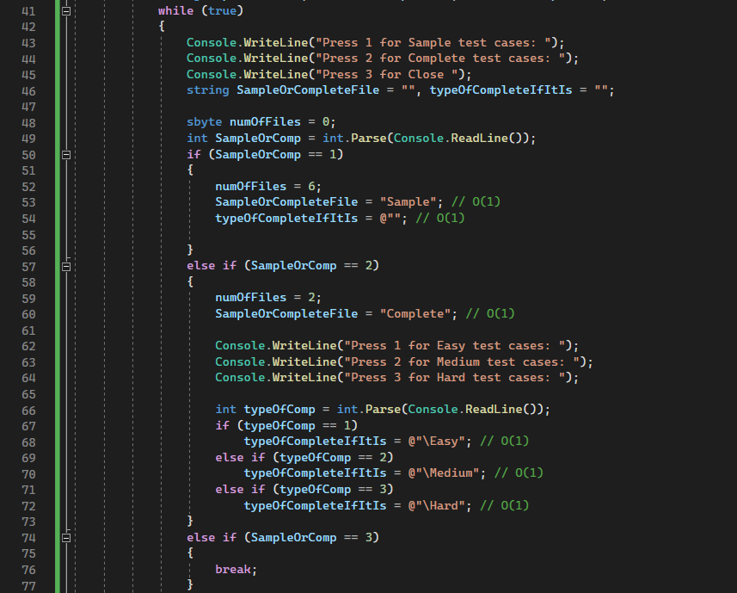

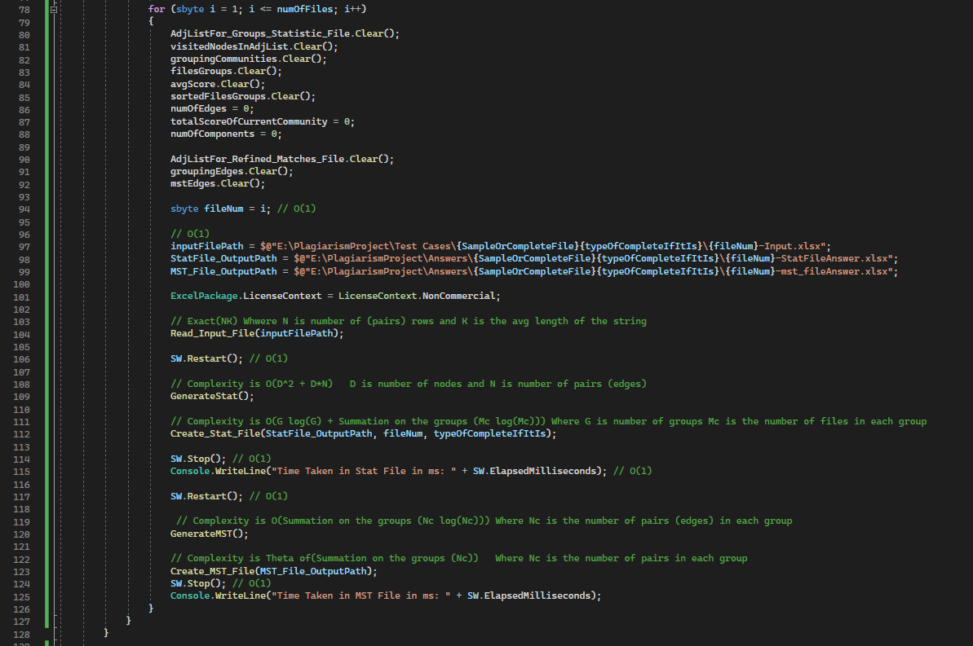

**Here We are initializing our data structures, and calling our functions.**

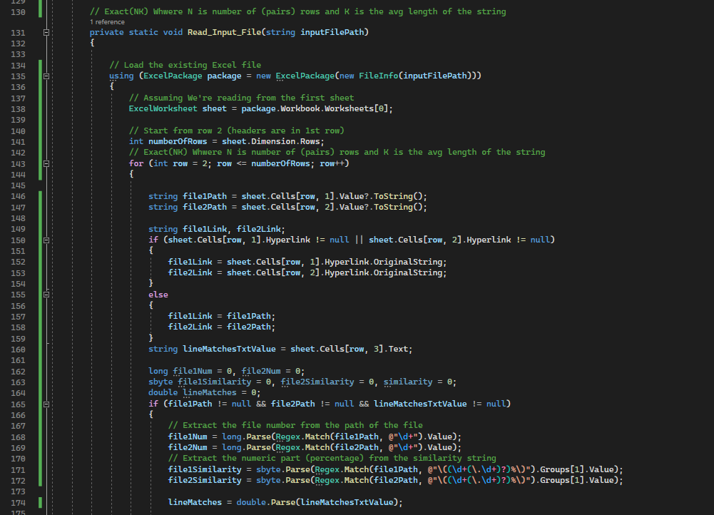

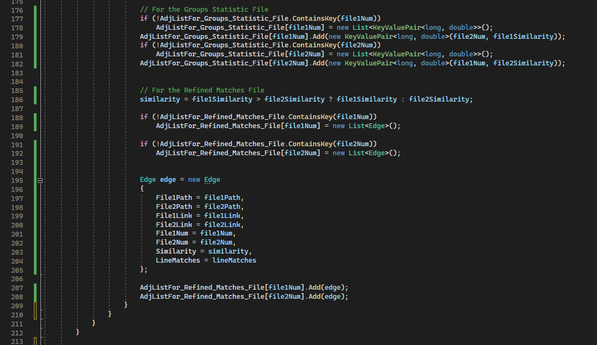

**The Complexity of reading the input file and graph construction is: Exact(NK)**

**where N is the number of (pairs) rows and K is the average length of the string.**

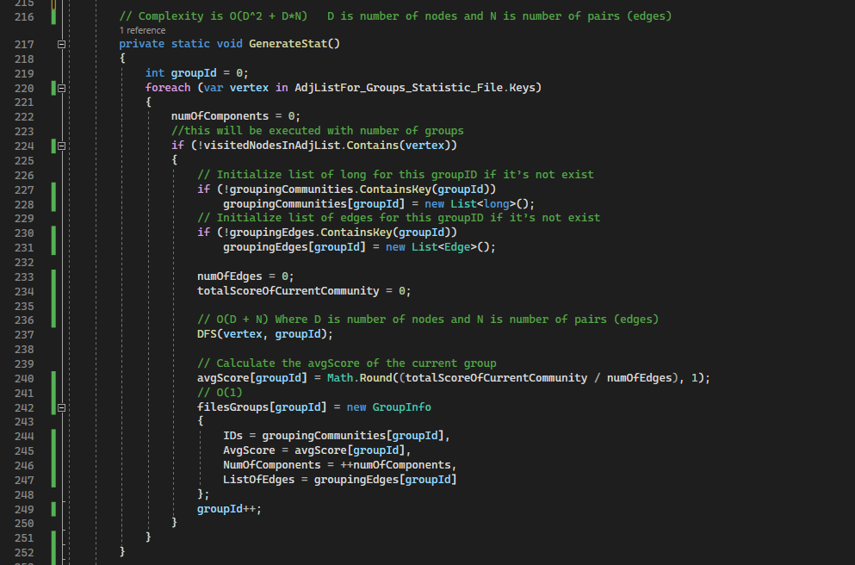

**The complexity of the State File Algorithm is: O(D^2 + D*N) where D is the number of nodes and N is the number of pairs (edges).**

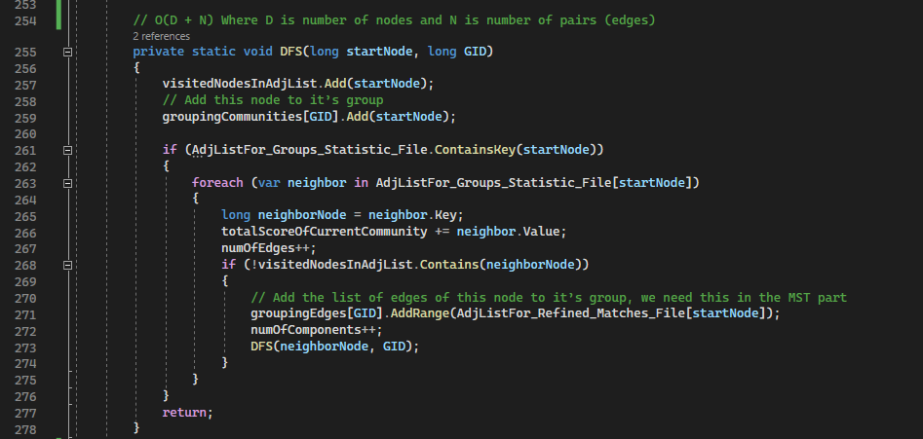

**The complexity of the DFS is: O(D + N) Where D is the number of nodes and N is the number of pairs (edges)**

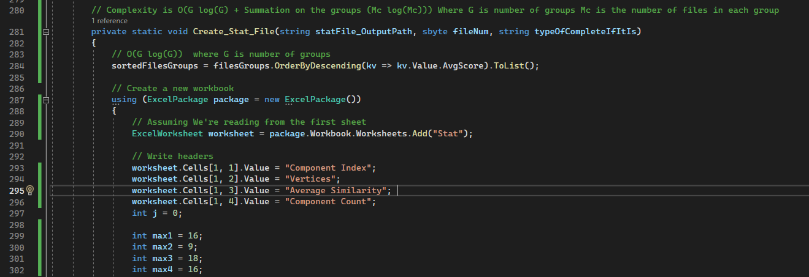

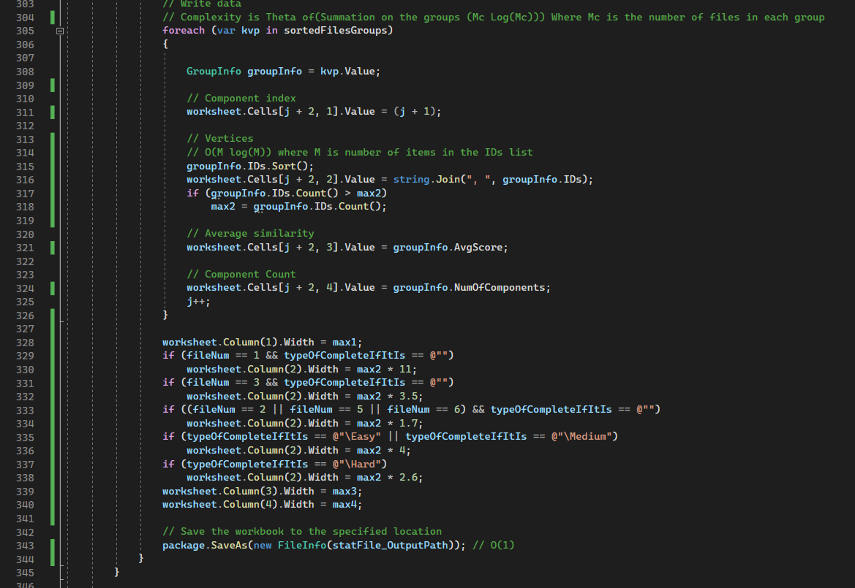

**The complexity of generating and saving State File is: O(G log(G) + Summation on the groups (Mc log(Mc))) Where G is the number of groups Mc is the number of files in each group.**

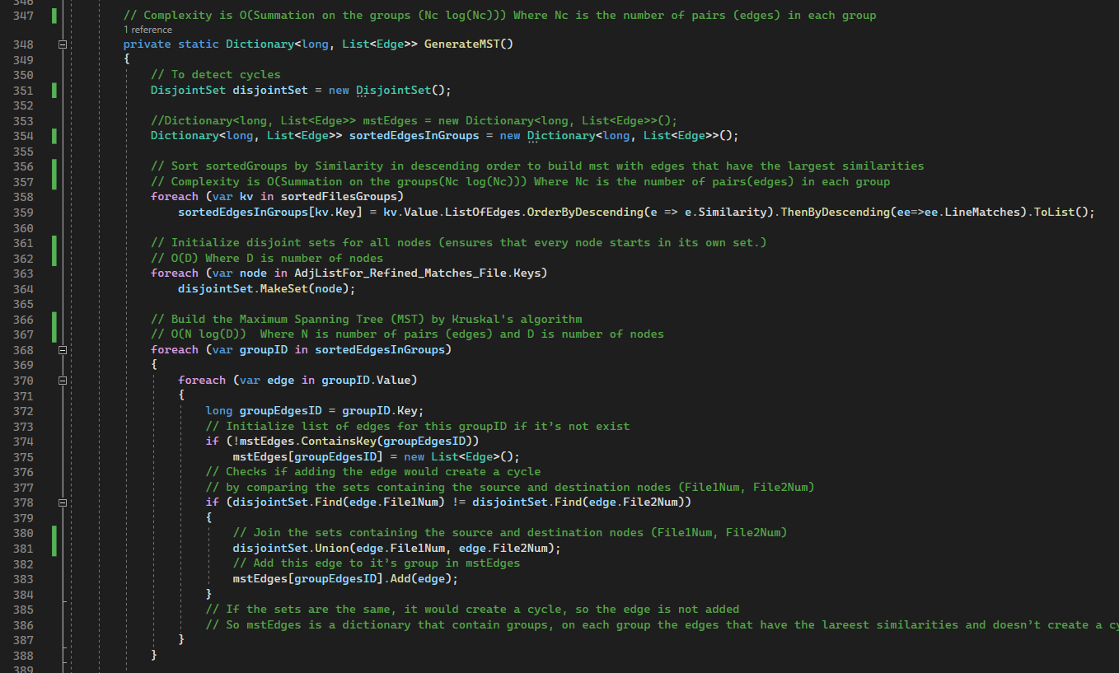

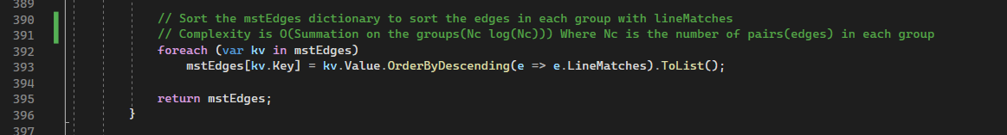

**The complexity of the MST Algorithm is: O(Summation on the groups (Nc log(Nc))) Where Nc is the number of pairs (edges) in each group.**

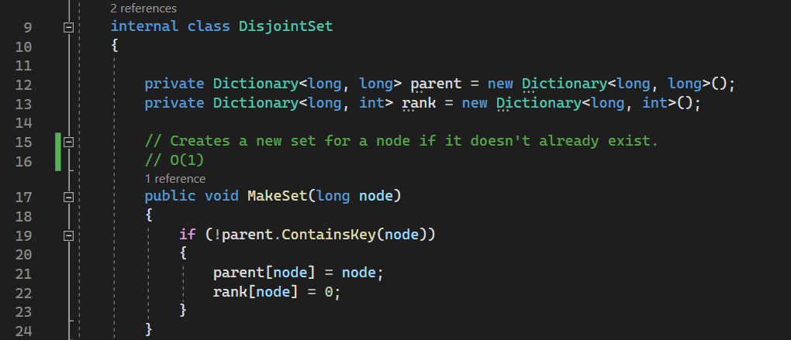

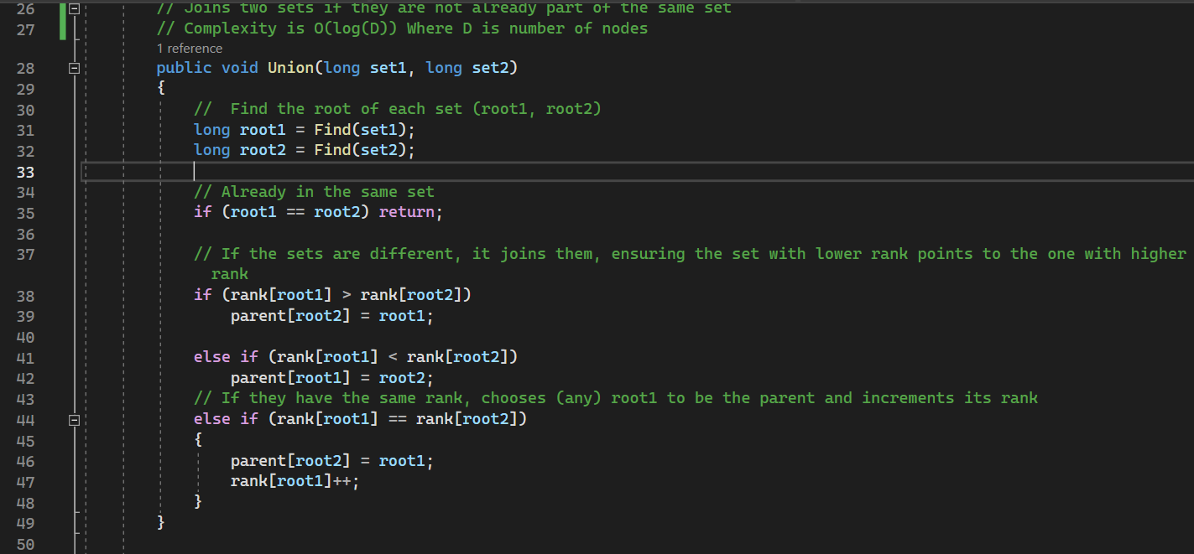

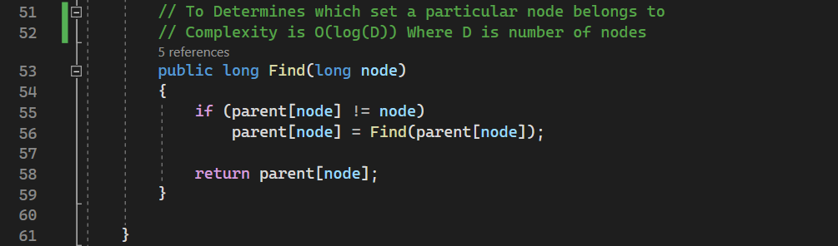

**This is the class for the used Disjoint sets forest**

* **The complexity of the MakeSet is: O(1).**
* **The complexity of the Union is: O(log(D)) Where D is number of nodes.**
* **The complexity of the Find is: O(log(D)) Where D is number of nodes.**

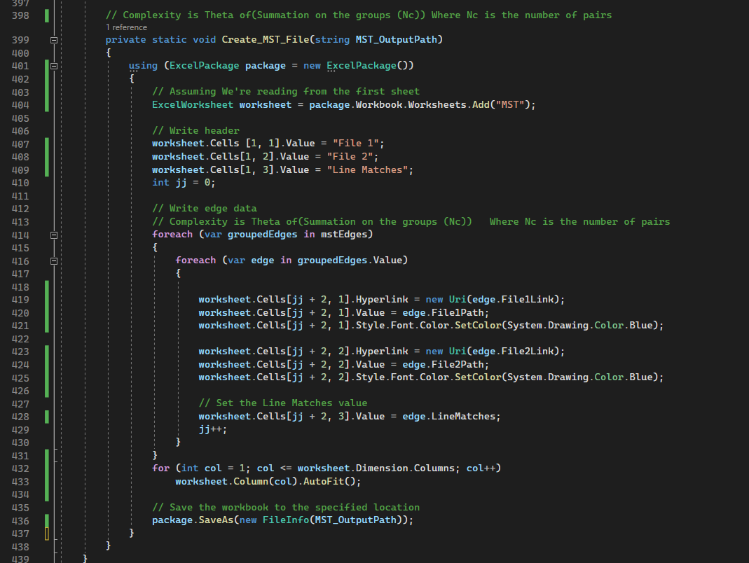

**The Complexity is: Theta of(Summation on the groups (Nc)) Where Nc is the number of pairs in each group.**

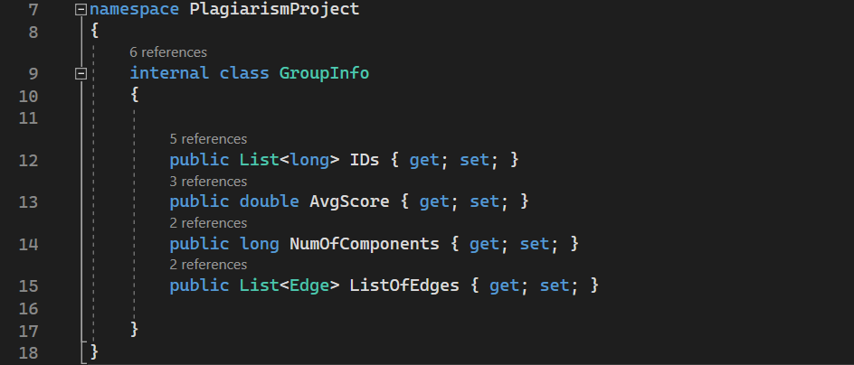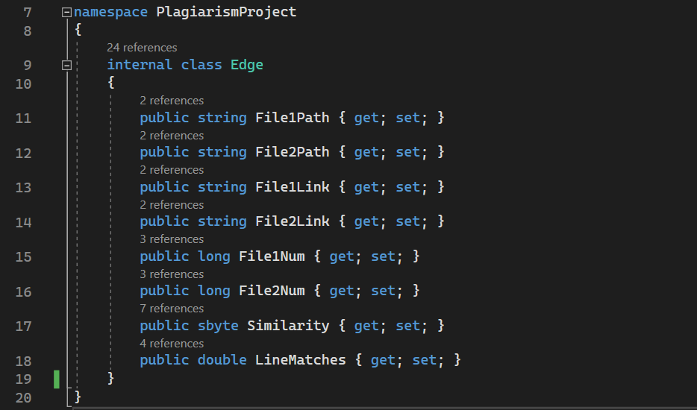

**These are the used classes in our data structures**

**The efficiency of the code through recording the execution time of complete cases:**

* **Easy:**
  + **1:**
    - **Stat File:**  6 ms
    - **MST File:** 29 ms
    - **Total Time:** 61 ms
  + **2:**
    - **Stat File:**  6 ms
    - **MST File:** 22 ms
    - **Total Time:** 55 ms
* **Medium:**
  + **1:**
    - **Stat File:**  6 ms
    - **MST File:** 54 ms
    - **Total Time:** 241 ms
  + **2:**
    - **Stat File:**  6 ms
    - **MST File:** 70 ms
    - **Total Time:** 246 ms
* **Hard:**
  + **1:**
    - **Stat File:**  30 ms
    - **MST File:** 2241 ms
    - **Total Time:** 2655 ms
  + **2:**
    - **Stat File:**  29 ms
    - **MST File:** 2112 ms
    - **Total Time:** 2940 ms